**NASA SPACE APPS CHALLENGE 2023**

**LIFE ON EXOPLANETS**

**AKASH TRIO MK 1**

**BY:**

**KARTHIK S**

**ROHIT M**

**SAMARTH BC**

**Description:**

**Our team strives to create and produce a unique idea of possibilities of life on exoplanets in the most creative, scientific and imaginative way possible.**

**The life on a planet is affected by various factors, for one to describe a life on a planet all these factors must be taken into account**

**The factors that majorly affect the reactions leading to life on the planet are:**

1. **The star around which the planet revolves**
2. **Planet’s geographical features**
3. **The atmosphere and the mineral composition of the planet**

**THE STAR:**

**The planet we gave life to revolves around a double star system. The double star system consists of an O and an A type stars revolving around their center of mass.**

**Star1 is of O type and Star2 is of A type. Both the stars are separated by a distance of 17,408,500 km. (25times radius of sun)**

**Star1 :**

**Star type: O**

**Radius: 7.5Rs**

**Mass: 15.6Ms**

**Metallicity: 0.01**

**Temperature: 33,500K**

**Luminosity level V**

**Star2 :**

**Star type: A**

**Radius: 2 Rs**

**Mass: 2 Ms**

**Metallicity: 0.02**

**Temperature: 7690K**

**Luminosity level IV**

**Distance between stars: 25Rs**

**Habitable region: 0.38au to 0.7au**

**Planet features:**

**Mass = 0.75 x 1024 kg (close to 1/8 Earth mass)**

**Radius = 2 x 1013 km (close to ½ Earth radius)**

**g = 10m/s**

**Ks = 20 kwatt/m2 (Solar insolation)**

**Z = 60o (Zenith angle)**

**Density = Same as earth**

**Formulas used:**

**Double star system formulas:**

**COM = m1r1 + m2r2 / m1+m2**

**Energy calculations:**

**E = Ks x Area of cross section**

**Ks = S cosZ**

**Z = cos-1(sinXsinY + cosXcosYcosH)**

**Z: Zenith angle**

**X: Latitude angle**

**Y: Solar declination**

**H: Hour angle**

**Gravitational formulas:**

**g = GM/R2**

**Habitable zone calculations:**

**Distance (HZ, star) = [Luminosity(star) / Luminosity (Sun)]0.5**

**luminosity = brightness x 12.57 x (distance)2**

**The living organisms live under water just the way all the organisms did before evolution of organisms on earth**

**The 3D representation is made available online on a webpage :-** [**https://akmi.vercel.app/**](https://akmi.vercel.app/)

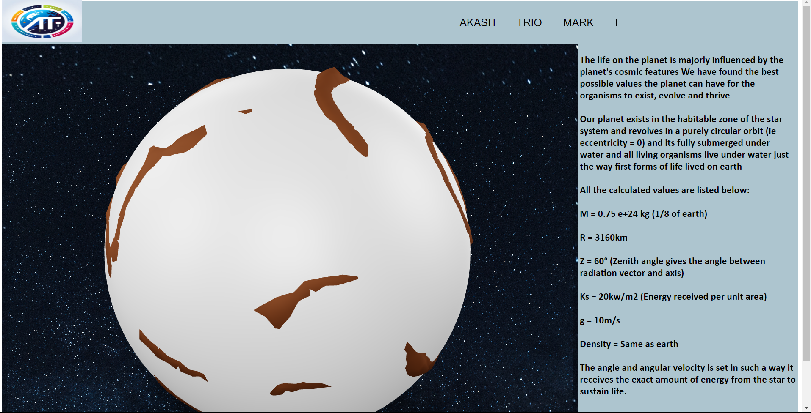

**ACKNOLEDGEMENTS:**

* [**https://www.spaceappschallenge.org/2023/challenges/habitable-exoplanets-creating-worlds-beyond-our-own/?tab=resources**](https://www.spaceappschallenge.org/2023/challenges/habitable-exoplanets-creating-worlds-beyond-our-own/?tab=resources)
* [**https://exoplanets.nasa.gov/discovery/exoplanet-catalog/**](https://exoplanets.nasa.gov/discovery/exoplanet-catalog/)
* [**https://www.omnicalculator.com/physics/luminosity**](https://www.omnicalculator.com/physics/luminosity)
* [**https://www.sciencedirect.com/topics/earth-and-planetary-sciences/zenith-angle**](https://www.sciencedirect.com/topics/earth-and-planetary-sciences/zenith-angle)
* [**https://www.britannica.com/science/O-type-star**](https://www.britannica.com/science/O-type-star)
* [**https://en.wikipedia.org/wiki/A-type_main-sequence_star**](https://en.wikipedia.org/wiki/A-type_main-sequence_star)
* [**https://www.omnicalculator.com/physics/orbital-period**](https://www.omnicalculator.com/physics/orbital-period)
* [**Wolfram|Alpha: Computational Intelligence (wolframalpha.com)**](https://www.wolframalpha.com/)
* **ChatGPT**